Prerequisites

1. Visual Studio 2017
2. IIS
3. Sql Server 2017
4. Visual Studio Code

Database setup

1. Locate Scripts.sql file under Others\Scripts folder.
2. Run above script in Sql Server. Press F5.

Update Web.Config

1. Locate web.config file under \Presentation\KPMG.Test.Web folder.
2. Update connection string with new database name.
3. You may also need to update username and password.
4. e.g. Server = localhost\SQLEXPRESS;User ID=username;Initial Catalog=KPMGTestDB;Password=password;Application Name=kpmg_test_spa;

IIS virtual directory setup

1. Open KPMG.Test.sln solution file in Visual Studio located under folder \jp097669.
2. Rebuild solution.
3. Open IIS.
4. Right click on Sites and click on Add Web Site.
5. Enter site name as [www.kpmg.com](http://www.kpmg.com)
6. Enter host name as [www.kpmg.com](http://www.kpmg.com)
7. Enter physical path of directory. e.g. C:\Code\Git\jp097669\Presentation\KPMG.Test.Web
8. Click ok to create web site.
9. 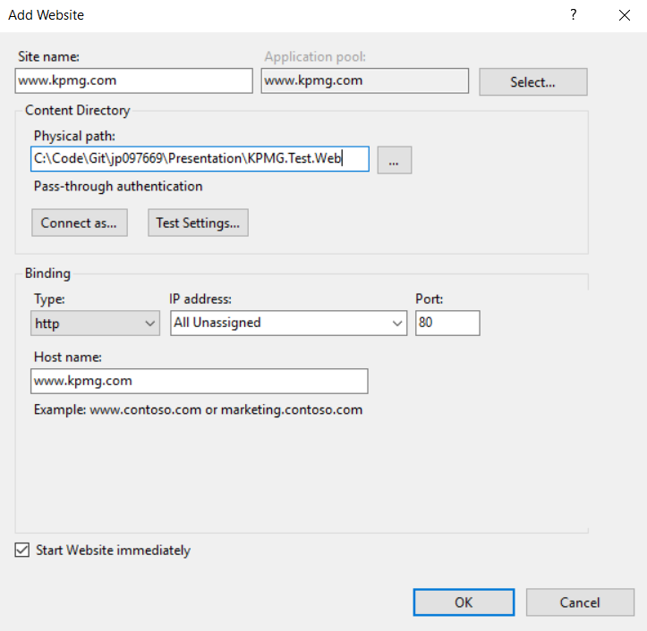
10. Navigate to C:\Windows\System32\drivers\etc on your machine.
11. Your local drive name may be different.
12. 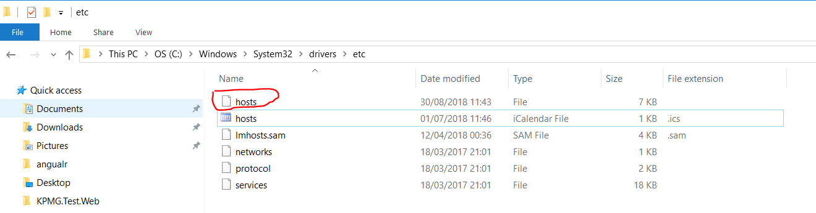
13. Open hosts file.
14. Add entry in hosts file
15. 127.0.0.1         [www.kpmg.com](http://www.kpmg.com)
16. 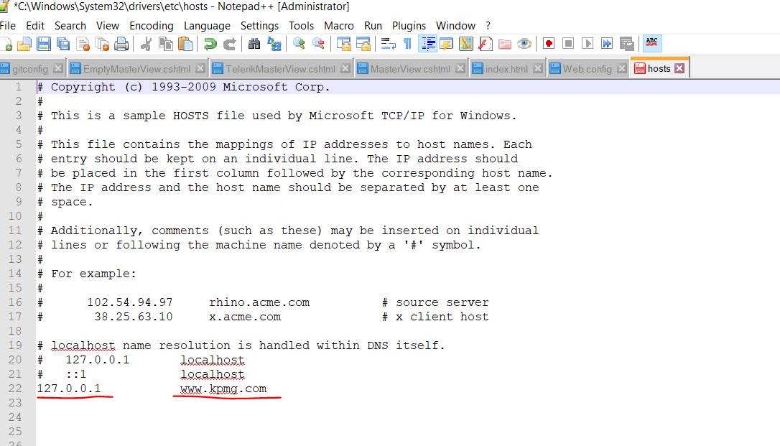
17. Save hosts file. You may need administrative rights to edit this file
18. Restart IIS
19. Open browser and type url [www.kpmg.com](http://www.kpmg.com).
20. To sign in as employee enter user name as employee_**1**. You can replace employee number from 1 to 500.
21. Enter password as password
22. Click on Login button
23. To sign in as publisher enter user name as publisher_**4**. You can replace publisher number from 1 to 10.
24. Enter password as password
25. Click on Login button

Run Integration Tests

1. Locate project KPMG.Test.ApiIntegrationTests or KPMG.Test.IntegrationTests
2. Open app.config file in above project.
3. Update connection string
4. Initial Catalog=KPMGTestDB_{0} must be in this format as tests will create and drop database
5. If you want to change database name e.g NewsDB then set Initial Catalog=NewsDB_{0}. Unit test will append guid to ensure tests are run in isolation

Run Unit Tests

1. To run unit tests you don't need to add/change connection string
2. Navigate to Test Explorer. & Run tests

Angular UI

1. Angular UI project is a web site project.
2. You can open jp097669\Presentation\KPMG.Test.AngularUI in Visual Studio Code.
3. @angular/cli version is 1.2.0
4. Commands
5. npm install -g @angular/cli@1.2.0
6. Above command will download required dependency.